Erasmus plus. KA1 course ‘How to make you school more international?
Organised by Euneos (www.euneos.fi)
Porto, 22-26 September 2014
Information about the course programme
http://www.ejournal.fi/course-international

Outcomes of the evaluation.
18 participants. Croatia 1 , Denmark 4, Finland 4, France 3, Latvia 1, the Netherlands 5

A. Preparation
Quality of the information supplied before the course on the website
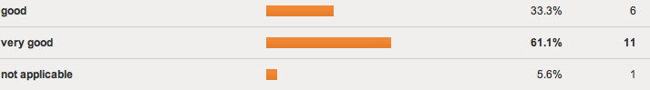
Sufficient and immediate answers to your personal mails
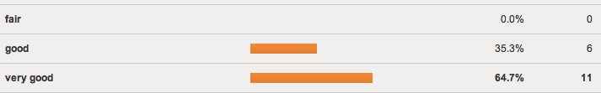
Mixxt (Closed social medium). Appropriate use of Mixxt to share information
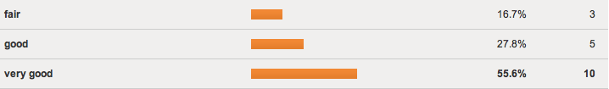
Mixxt (Closed social medium). Suitability of Mixxt to get to know each other
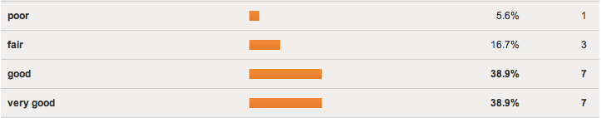

B. Quality of the course
1. Quality of the course programme in general
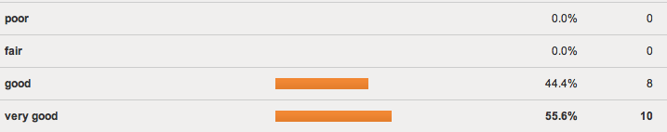
2. How interesting was the information provided in the presentations / introductions on

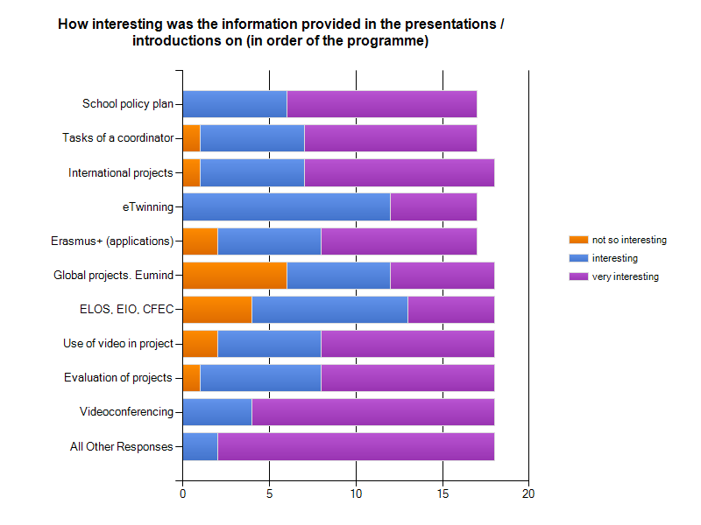

3. Quality of the trainers
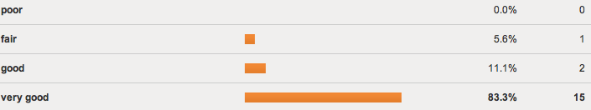

A formation very well prepared and rich; a timing very respected; the long experience of the trainers and their energy, their enthusiasm , their disposability motivated us to go further in internationalization in our school. Excellent ambassadors.

Very nice and friendly people who knew what they were talking about. Always ready to help and meet the specific needs of the course attendants.

Thank you so much the three of you! You are in my top 10 of best teachers I have ever met. Really true! The humor is an important thing in your lessons so you always get the attention back from us. Also a lot of knowledge you have where you can be very proud of. You were helping a lot of people this week all over the world!

Very well prepared, very supportive.

The first three days were specially very good and the rest of the week good. Somehow the timetables weren't as precise in Thursday than in the beginning of the week

It was nice that all three of you had some presentation. It was good that we ourselves tried the things we just heard about, so that there was a mix between listening and working ourselves.

Very good trainers, wery informativ and they understood to match the course whit our needs and were able to alter course when needed

The course would have benefitted from a more interactive approach at times, eg. it would have interesting to get feedback on the results of the balance between 'work and play' that we worked on. The topics in general were quite interesting, both for beginners and more advanced students.

Committed, efficient, helpful

More interaction between the speeches. Better evaluation after assignments between students

The course was very professional and the output of trainers was excellent.

4. Quality of the documents materials on the course platform (course documents, additional documents, links to websites etc.)
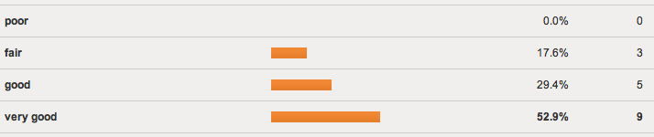

5. Methodology of the course. Was there a good balance between the three parts of the course (information, sharing experiences, working on own outcomes) If you would have liked it differently, please comment for which part you would have liked to get more time

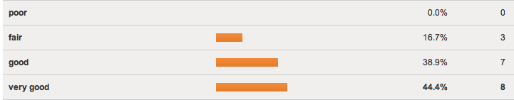
It was good to work in mixed groups and share experiences. I appreciate exercises with ludic aspect.

At the beginning it felt as if there was too much information to be covered but as the course went on you got the hang of it. There was enough time for reflectation and making contacts with others

The tasks of Friday were really good. Maybe in the beginning there could have been more time to share experiences, but in all we had time for that during the whole week. In myself didn't need the half an hour every morning to be asked where are you now with your weekly tasks. But maybe you need that for the Erasmus+ agency?

The start of the course was very effective and even a bit tirening because all of the information. But it was good to get the things started in the beginning.

the information part could be more compacted

Perhaps some morning classes could have been optional, so that participants had more time to work on specific goals.

We did not have time to finish our work. Sometimes I think group work ends up in chatting about different experiences but the tangible outcome can be hard to grasp. However the balance was very good, we might just need a bit more time

Working on own outcomes could have been better guided and evaluated

There is room for more ICT based activities. There was a bit too much one way information for my taste.

We had a lot of oppotunities to discuss with each other. All the participants had so much to give.

C. Intellectual outputs /Expectations met?
1. The KA1 application insists on 'learning agreements' between the participants and the course providers. To what extent did the course meet your expectations in general
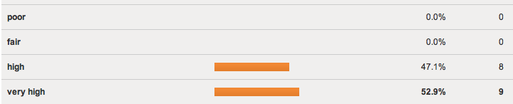

2. To what extent did the course meet your specific expectations (see Monday morning session).
Select 10 most important expectations. For the others tick not applicable.

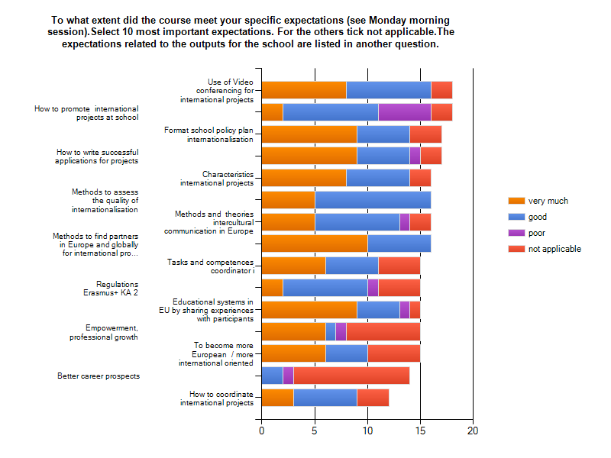

3. The KA1 application insists on creating outputs to be delivered during the course To what extent are you satsified with your products?

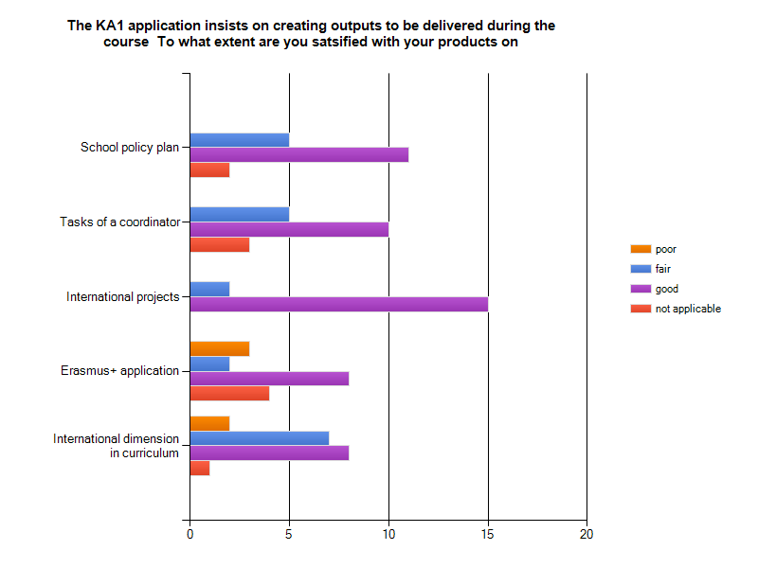

C. Effects of the training.

1. Effect of the course on your school. Explain how the course will contribute to 'make your school more international'. What are you going to do from October 2014 - till June 2015 to 'make your school more international' How will you do it and with whom?

1 Constitution of the international team in the school
2 project eTwinning with an already found portuguese school
3 convince school, region, education administration of the necessity in my regions to be more international

1. We will introduce the school policy plan to the head and the teachers of the school
2. we will start eTwinning co operation with our partner school
3. we will try to get as many teachers to be part of the projects as possible

1. Start working on our school policy plan with my headmaster and my colleagues with the help of the school from The Netherlands
2. Start working on preparing KA1 activity together with the school from the Netherlands in which we will include job shadowing
3. Realisation of etwinning project with Latvia and the Netherlands( not the same school as for job shadowing)
4. Start working on our unsuccessful KA2 application

1. Refining the tasks of international coordinator - it will be done together with the international coordinators
2. Starting a new international project (eTwinnning, video conference or a mobility) with someone in this course :) - teachers from both schools
3. Applying for KA2 application next spring, with partnerschools

1. We have an international team at our school to plan all the projects. First of all we have to discuss about our school's international plan together. We completed the plan here at the course and sent it to our headmaster yesterday. 2. We start our virtual projects during this autumn.
3. In a plan we have all the theme days we will spend at school in this year. And hopefully some year in the future we will also apply some international projects.

1. Stay in contact with new partners in Europe gained in integrating more subjects at our school write the new applications KA1
2 work together with the headmaster on school policy
3. start several entwining virtual projects
4. hink about structuring the tasks of the coordinator

1. I will present the school policy plan to my leader and discuss about the contents. My leader will have to present it to the whole school, and my job is to give ideas to my collegues and assist them in their future work.
2. We have to have focus on which classes that have done what, and spread theese stories to the rest of the collegues, so the they esily can get ideas for their own projects, and so that they don't feel it like more work.

I have started one project with one other country and has made severeal contacts for me and my colleagues. We have worked on a school policy plan to make the school more international and how to implement it in our curriculum we will be working with the purpose of getting projects

Rewrite school policy plan apply for KA1 apply for KA2 with new partners entwining projects with several schools from this course involve primary schools in internationalization

1. Make clear to the board what is needed in order to get a high priority for internationalization and let the board spread the message of what is needed to be done
2. Divide my created contacts out to my colleagues

1. Organize eTwinning project with the partners found on the course
2. Inform and discuss future prospects on internationalization of our school with the colleagues back home
3. Work on KA2 application for March 2015

1 We will complete our school policy plan and we will submit it to the management
2 We will apply for KA1 with our partner school
3. We will set up a team
4 We will report on our courses to the management, the teachers, the local authorities

Try different small projects with new partners through Itwinning. Keep in touch with other students from this course about there outcomes

1. I am going to rewrite the school policy on internationalization and make it sustainable for more years. We have to place a solid foundation by searching for new partners and expanding the projects, varying from very small projects from the classroom to KA2 projects with exchanges.
2. by collaborating with a group of enthusiastic teachers that think that internationalization is a asset to there daily work.

I have contacts I can share with my colleagues. I also got a better understanding for what internationalisation is, and how I can find that in things we already do in school.

1. We will present our policy plan to School administration
2. start working step by step with The plan
3. Start working with the contacts/projects we gained

2. The course encouraged me to adopt a more reflective approach to the way I carry out my tasks for international projects
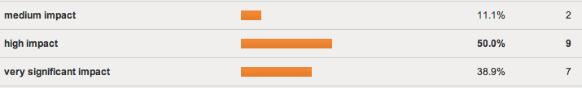
2. The course motivated me to carry on developing my professional skills in the future

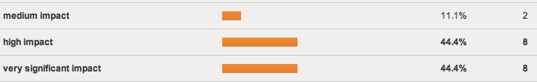
3. The course led or will lead to establishing partnerships/ co-operation with schools represented at the training event
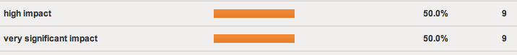

D. European dimension and intercultural learning.
What have you learnt about cultural differences while working together? How did you cope with differences? / Was there any evidence of mutual trust?
Even if we were coming from different countries, we were all "opened" to the other and curious to discover the culture of each other
9

At this course it was very easy to cope with people from different cultural back grounds. Everybody seemed to have a common goal of working together, making contacts so there was definitely a mutual trust. Not difficult to cope with the differences , the atmosphere was very positive and open.

I had no problem with cultural differences.

It is nice to see how people are thinking differently and how they are performing different kinds of way, but I am used to different kinds of international people. So it wasn't a surprise. What actually surprised me was that everyone was eager to share his/her own knowledge about different issues. I think I got a lot from other participants.

I learned a lot. The group discussions were almost the best part to me, I enjoyed to get to know new colleagues. I think we coped the differencies in a very tolerant way.

keep in touch and keep on listening to each other

i have learnt a lot about different ways schoolsystemes work in eu

learnt a lot, enjoyed the differences, established mutual trust, absolutely

we have had lots of conversations about how to be a coordinator and we got to know the other participants very well

We had a very nice and easy to work with group. I did not encounter any problems and it was easy to cope with cultural differences.

We were aware of differences but, being a group of highly motivated participants, we worked very well together with respect and trust.

We are more alike then I thought. We will have to wait and see if the contact stays as good as we will hope.

There are no differences on a personal level, only biases that come from poor information about groups.

Learned a lot from collegues from the different countries, about methods, different school systems, how important it is to talk about culture differences and similarities

E. Give a mark for the in-service training activity (content and methodology) as you would do on a platform 'Course advisor' (like trip advisor, booking.com for hotels)
9 is very good - 8 is good - 7 = fair - 6 = poor

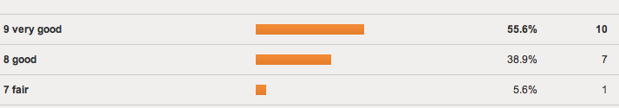

Annex 1. Monitoring the progress of the outputs.
Day 1. Morning session. Inventory of the areas of interest and of the intellectual outputs to be delivered by the participants. Every participant got 4 stickers to indicate the most important areas
Blue = most important outcome to be obtained / Red: second most important
Green.. Third most important / Yellow. Fourth most important

See Results Selfevaluation above in C.3
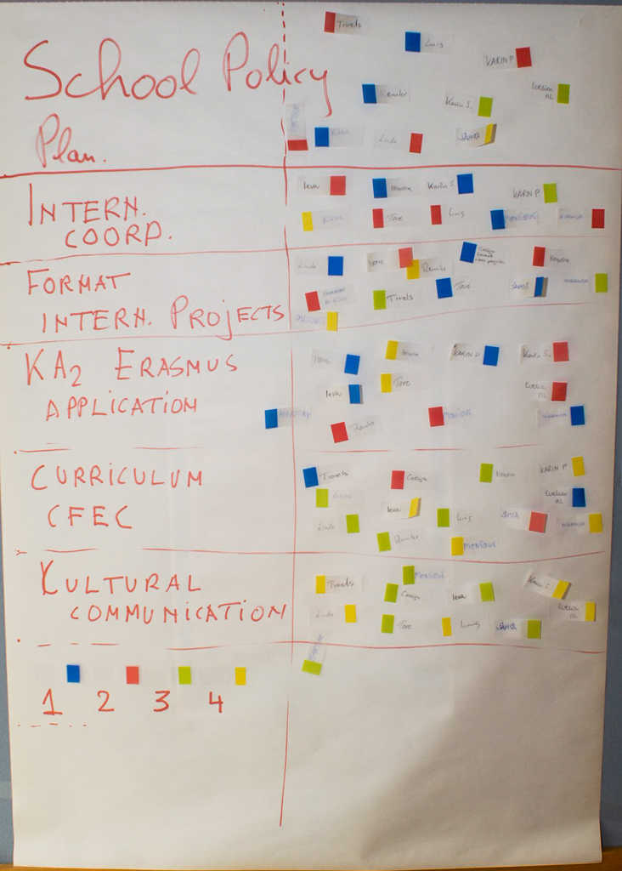
Annex 2. Programme of the course
Sunday 21 September
Arrival
Welcome dinner: getting to know each other (optional)

Monday 22 September
9.00 - 10.00 | Plenary session together with participants of Euneos 'Tap-Swipe-Pinch' course.  Welcome and official opening.  Conference folders and badges; presentation trainers; practical arrangements. Getting to know each other. Information on partner search for school projects.
10.00 - 10.30 | Break
10.30 - 11.30 | Introduction group members. Expectations: what do you want to learn?  Introduction course programme
11.30 – 12.30 | Introduction topic 1: Developing a school policy plan on internationalisation and sharing experiences  Frans Schmitz
13.00 - 14.00 | Lunch
14.00 – 14.45 | Introduction topic 2: How to become a good coordinator of internationalisation.  Tasks of a coordinator. Sharing experiences.  Ludo Mateusen
14.45 – 16.15 | Creating intellectual output.  Participants work individually or in groups on:  - a first draft of a school policy plan. Focus on Mission statement of the school, objectives of internationalisation, quality of international projects;  - or: presentation for their own school management and own colleagues  - or: a first draft of tasks of coordinators of internationalisation
16.15 – 16.30 | Reflections

Tuesday 23 September
9.00 - 9.30 | Programme of the day / overview.  Result of partner search for projects.
9.30 - 10.30 | Introduction topic 3: Developing formats of international project work (exchanges and virtual projects). Ludo Mateusen
10.30 - 11.00 | Break
11.00 – 11.30 | Introduction e-Twinning (Video conference)  Jan Hormann, Netherlands. Winner of e-Twinning labels and e-Twinning ambassador NL
11.30 - 13.00 | Sharing experiences 'Best practices' virtual projects, programmes of exchanges
13.00 - 14.00 | Lunch
14.00 – 15.00 | Creating intellectual output.  Participants work individually or in groups on  school policy plan. Focus on quality of international project work in the school policy plan  OR  presentation for their own school management and own colleagues | Creating intellectual output international projects  Developing concrete projects and project scenarios:
15.00 | Sightseeing Porto

Wednesday 24 September
9.00 - 9.30 | Programme of the day / overview.
9.30 - 10.30 | Introduction topic 4. How to set up a multilateral, bilateral, Regio Partnership in Erasmus + and how to apply successfully for an Erasmus+ grant KA2  Ludo Mateusen
10.30 - 11.00 | Break
11.30 – 12.30 | Share experiences on topic 4.  Schools who have taken part in Comenius projects under the LLL-programme report on their experiences.  Schools who have applied for an Erasmus+ Strategic partnership share their experiences.
12.30 - 13.00 | Global projects. Introduction Eumind. Ludo Mateusen
13.00 - 14.00 | Lunch
14.00 – 15.30 | Creating intellectual output.  Assessing a given exampe of an application for Erasmus plus partnership against the assessment criteria  OR  Filling in parts of the application form  (Project description, preparation, priorities) | Creating intellectual output. Continuation of working  - Groups school policy plan  - Presentation for own school  - Groups international projects  Partner search: developing own project
15.30 – 17.00 | Personal guidance

Thursday 25 September
9.00 - 9.45 | Programme of the day / overview.  Reporting on the works so far
9.45 - 10.30 | Introduction topic 5. Internationalisation in the curriculum. Introduction to the Common Framework of Europe Competence and ELOS (Education stretching borders)  Frans Schmitz
10.30 - 11.00 | Break
11.30 – 13.00 | Use of video in projects (didactical approach and examples). Ludo Mateusen
13.00 - 14.00 | Lunch
14.00 – 15.30 | Creating intellectual output.  - How can we include the Common Framework of Europe Competence in the school policy plan?  - How can we relate the the Common Framework of Europe Competence to a project?  OR  Creating intellectual output. Continuation of working  - Groups school policy plan  - Groups international projects  OR
15.30 – 17.00 | Personal guidance

Friday 26 September

9.00 - 9.30 | Introduction . Evaluation of international projects. Lud Mateusen
9.30 - 10.30 | Use and organisation of video conferences in international projects. Introduction Zoom.us  Annemie Mateusen
10.30 - 11.00 | Break
11.00 – 13.00 | Introduction topic 6. Intercultural communication and competences. Atlas of European Values  How to develop the intercultural competences of the teachers taking part in international projects.  Ludo Mateusen
13.00 - 14.00 | Lunch
14.00 – 15.30 | Presentation of intellectual outputs  International projects (set up during this course).  School policy plans.  Erasmus plus projects and applications.  Common Framework in relation to school policy plan or project
15.30 – 16.00 | Filling in online evaluation of the course
16.00 - 17.00 | Final session  Follow-up, networking  Certificates

Annex 3. Participants and trainers.

